Create a JS HTML form for Sum of 2 numbers
Using normal textboxes and readonly result textbox
If no values in textboxes and pressed tab (onblur), background should be red and result error

Hint - .style.backgroundColor = "white";

If non numeric values background should be yellow
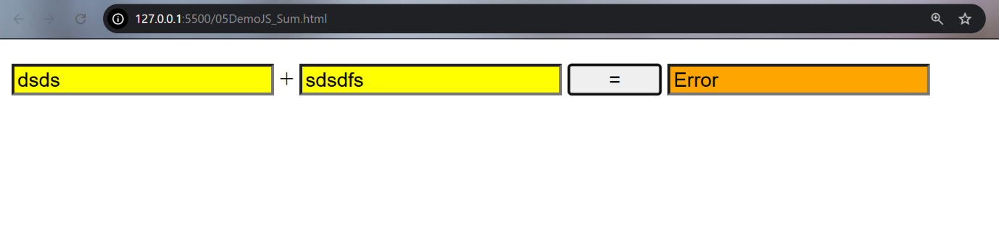

If valid numbers entered, , background should be white and result displayed
